M&E UX PROJECT DOCUMENTATION
Admin dashboard:
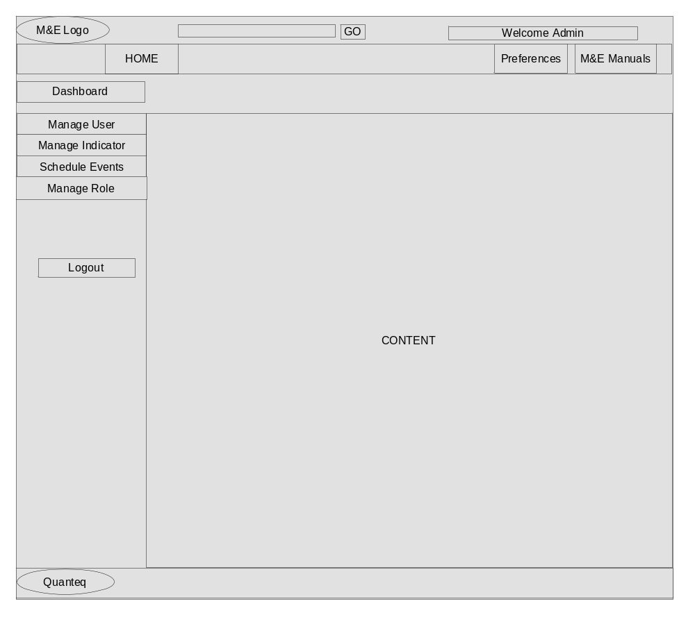
The admin dashboard is divided into two sections:
- The left sidebar which consists of the manage user, manage indicator, … and
- The content area.
- Tab the ‘Manage User’ menu to manage users (Teams and members).
- Tab the ‘Manage Indicator’ menu to manage indicators (classes of indicators and questions).
- Tab the ‘Schedule Event’ menu to manage events (manage address, time, facility,...)
- Tab the ‘Manage Role’ menu to manage roles and permission.
Manage User Screen:
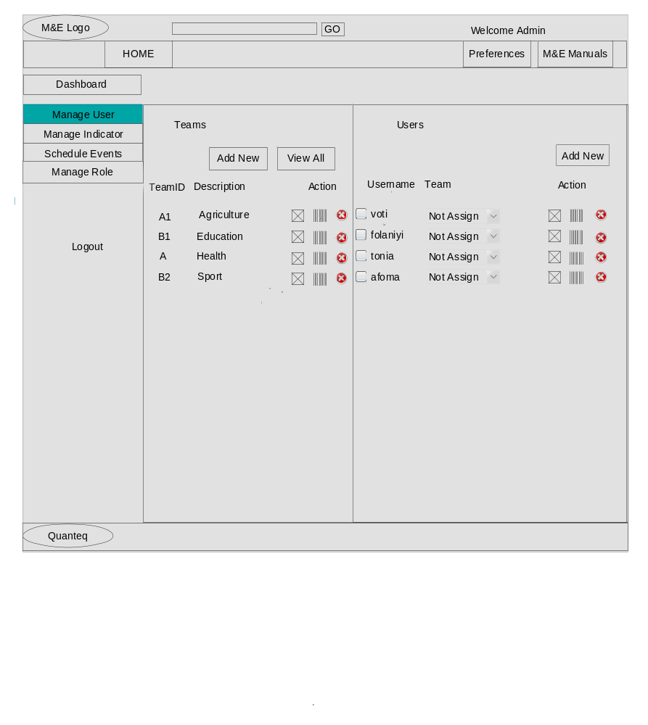The manage user screen consists of two sections:
- Manage teams and
- Manage users(members)
- The manage team section displays all teams, the actions and two buttons to add new team and view all members under a team
- The icon before each user simply indicate active/inactive user
- The icons under ‘action’:
- Click to manage user role and permissions.
- Click to set user status (active/not active) and change password.
- Click to remove user (team/member).
- Click the add new button to add new team/user.
- Click the view all button to view members of a team.

Manage User_add new user pop-up screen:
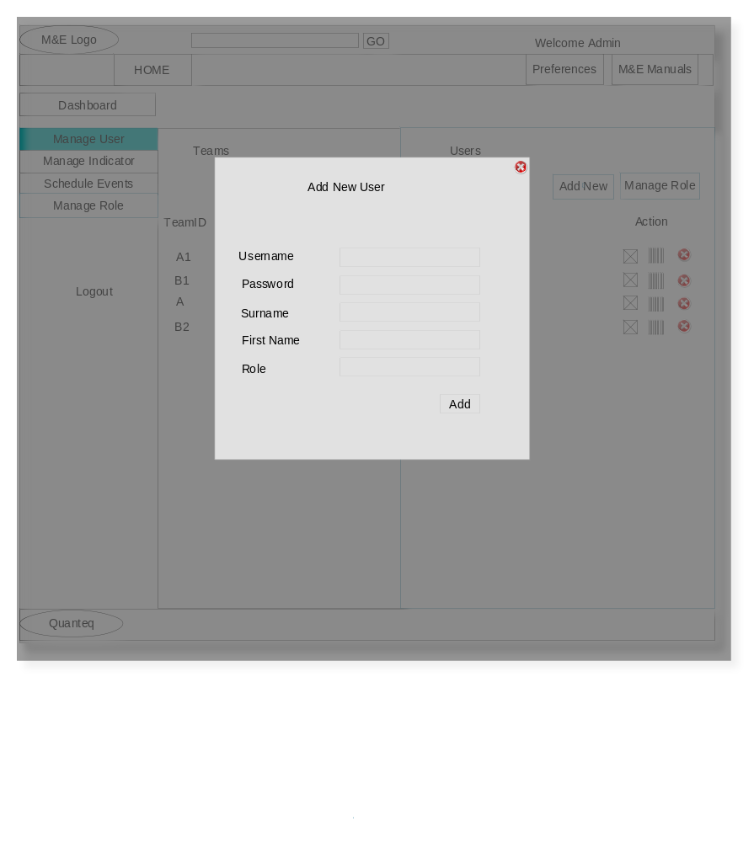
The add new button allow one to add new user and assign a role to the user.

Manage User_add new team pop-up screen:
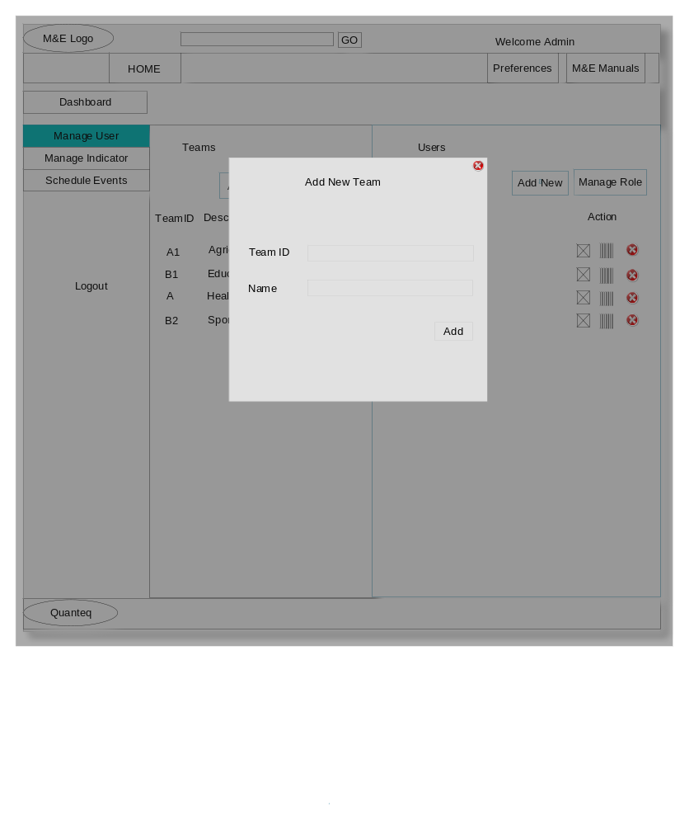
The add new team pop-up screen allow one to add a new team.

Manage Indicator Screen:
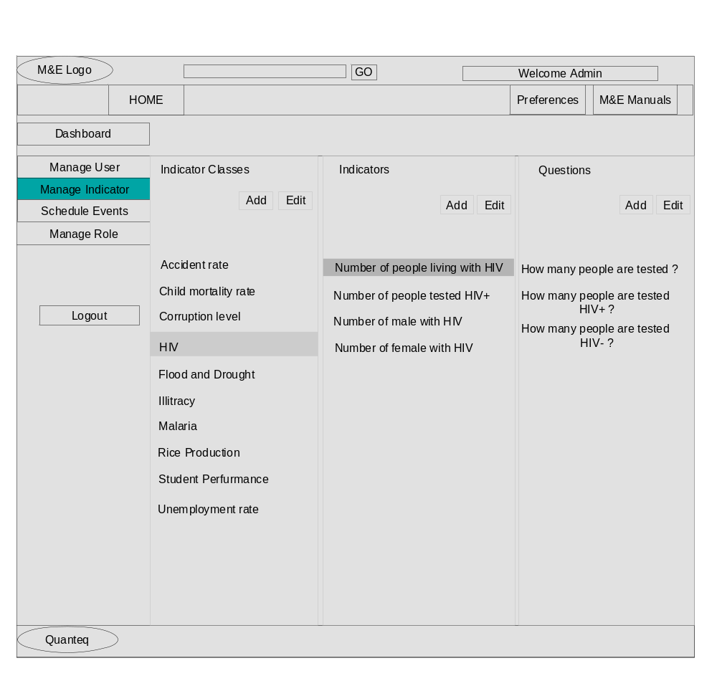
The above screen is divided into three columns:
- The indicator class column enable one to manage indicator classes
- The indicator column enable one to manage indicators and
- The question column manages questions for indicator.
- Tab a menu (HIV) on indicator class column, it display the indicators to that class(HIV).
- Tab the indicator menu (Number of people living with HIV), display the questions to that indicator.
- Click the checkbox beside each question to remove question
- Tab the ‘Add’ button for each column to add new class, indicator and question.
- Tab ‘Edit’ to reset status.

Manage-Indicator add new indicator class pop-up screen:
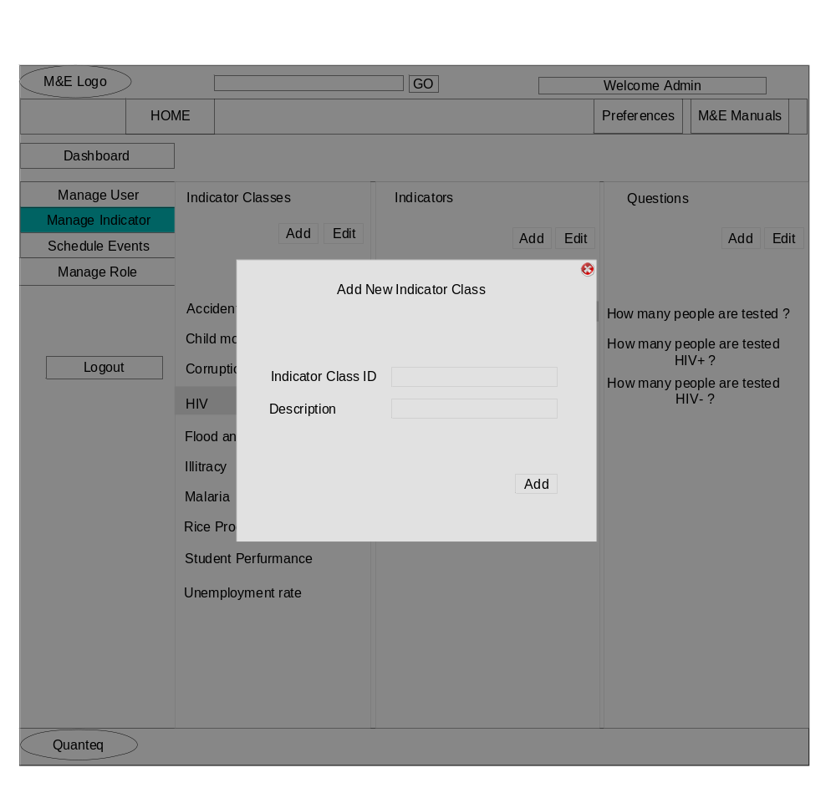
- Enter values into the text fields on the pop screen and
- Click on add to add new indicator class.

Manage-Indicator add new indicator pop-up screen:
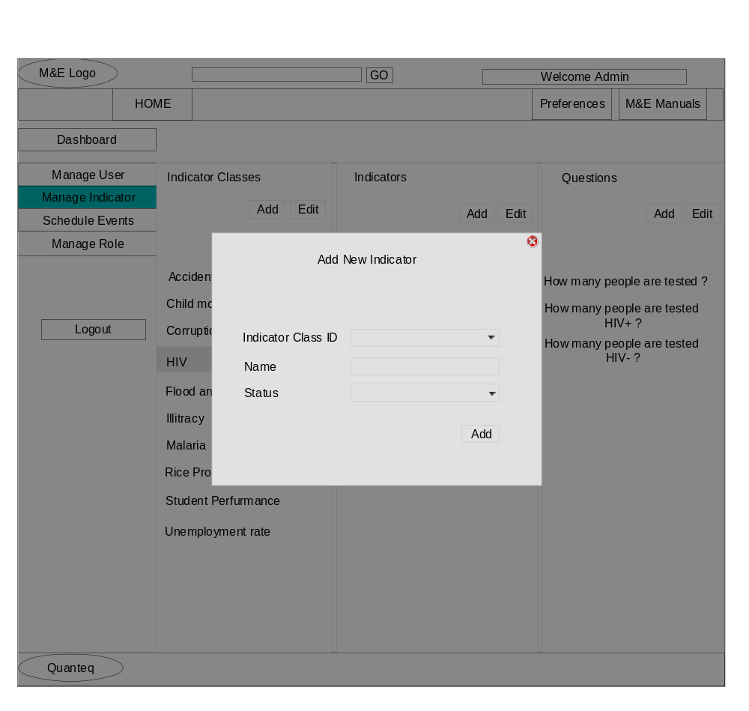1. The pop-up screen above enable user to add new indicator.
2. Tab the dropdown fields to select indicator class and status.
3. Type the new indicator in the Name’s input field.
4. Click on add button to submit.

Manage-Indicator edit indicator pop-up screen:
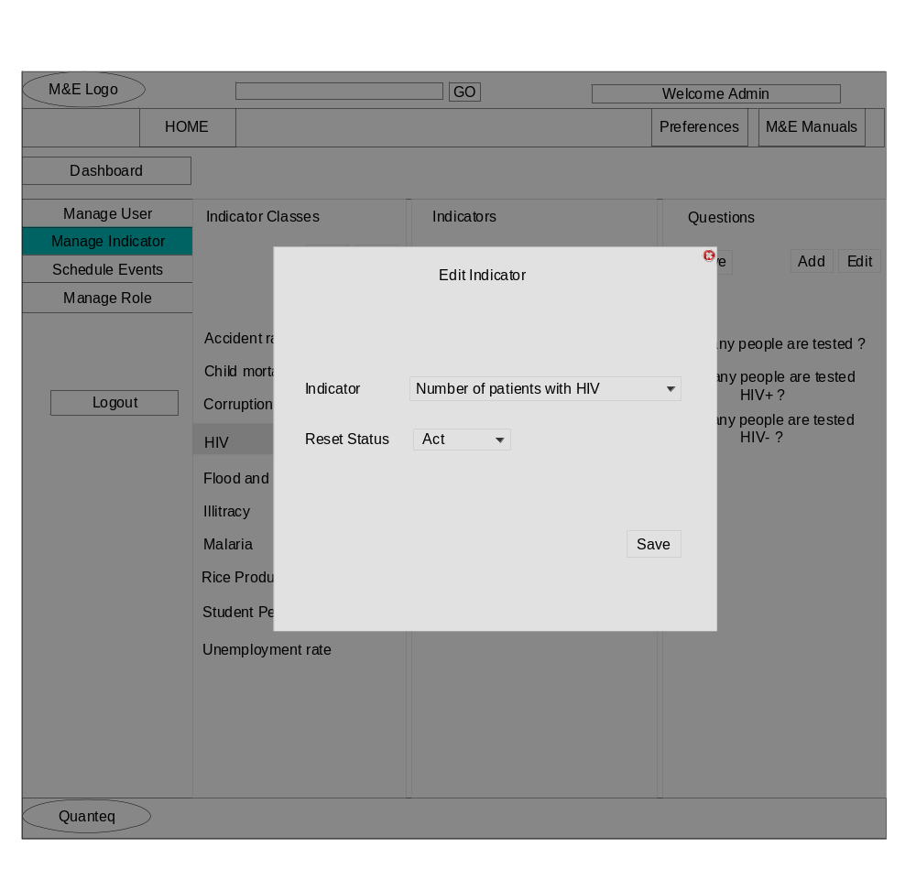
- Click the indicator field to select indicator and
- click reset status field to select status.
- Click save to effect changes.

Manage-indicator add question pop-up screen:
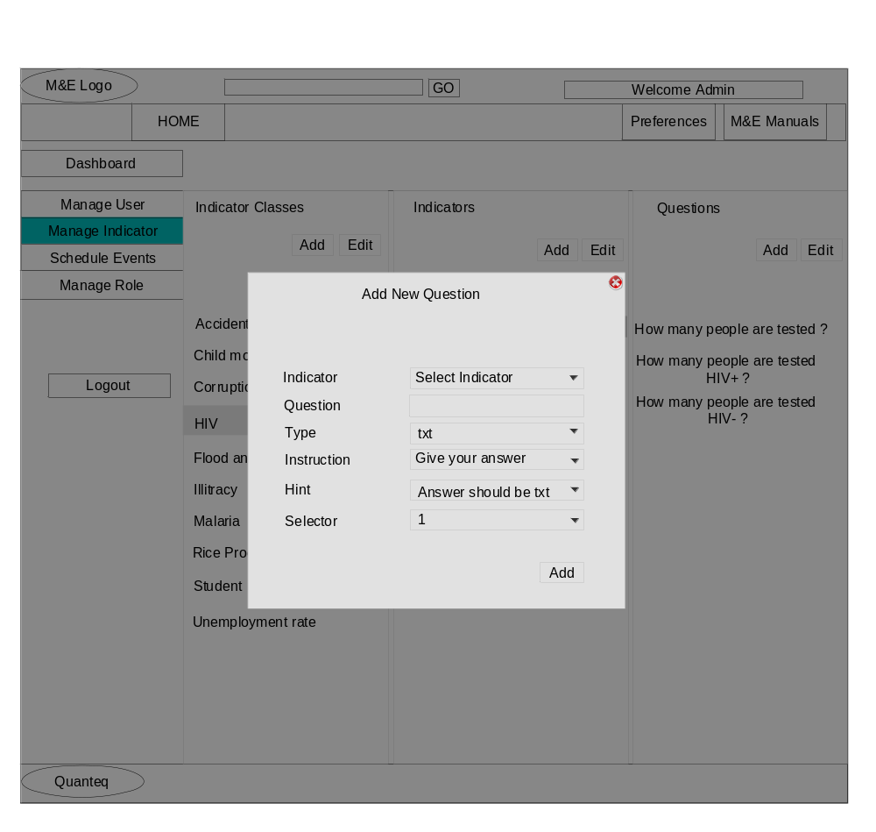
- Click the indicator dropdown field to select indicator.
- Enter text values to question text field.
- Click Type dropdown menu to select question type text.
- Click instruction, hint and selector dropdown menus to select instruction about a question, hint about question and question selector.

Manage-indicator edit question pop-up screen:
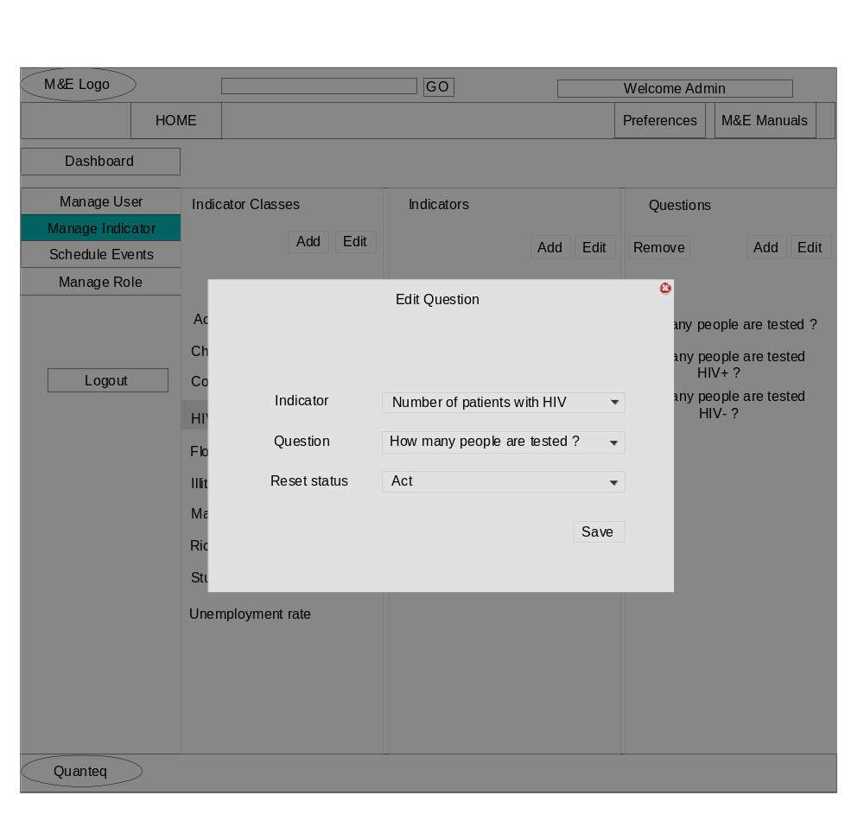
- Click indicator dropdown field to select indicator.
- Click question dropdown to select question.
- Click reset field to select status(active/not active).
- Tab button save to effect changes

Manage-indicator remove question screen:
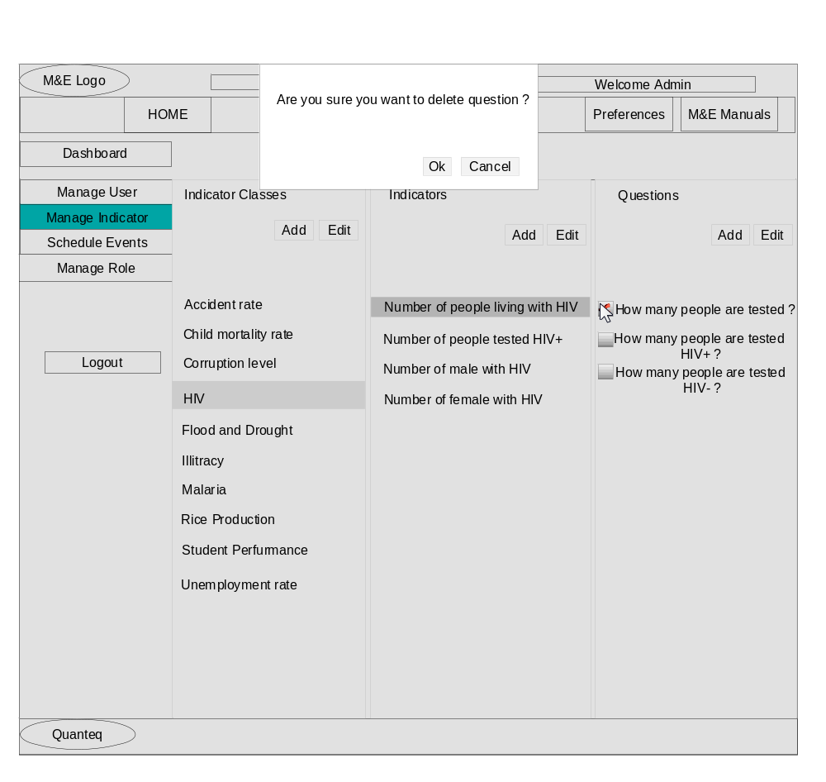
Click on button beside each question and a small screen appears at the top; click ok button to delete or cancel button to exit.

Manage-Role Screen:
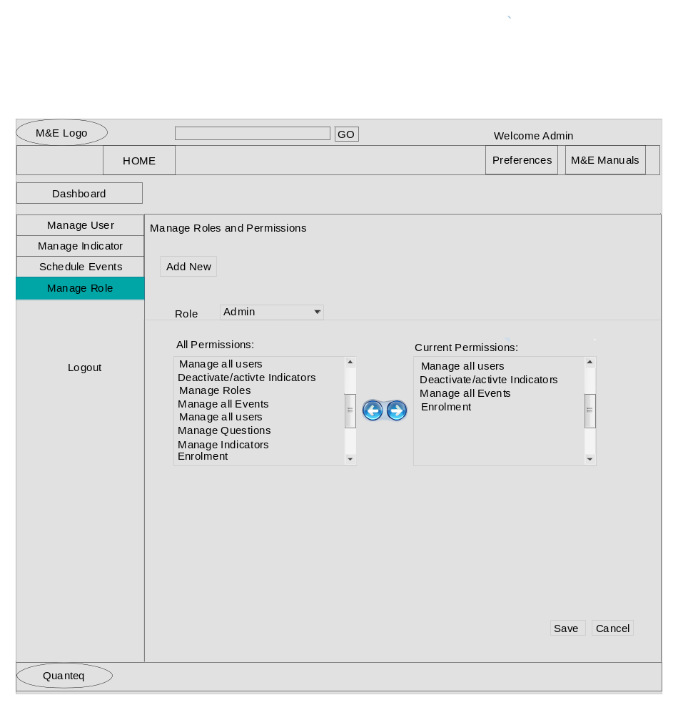
The manage role screen consists of buttons, combo box, left and right list boxes and left-right navigation button.
- Click on add new button to add new role.
- Tab on role combo box to select role.
- The left list box composed of all permissions and the right is composed of current added permissions. Select any text value, click navigation button to add values either directions
- Click save button to effect change or cancel button to exit.

Manage-Role add new role pop-up screen:
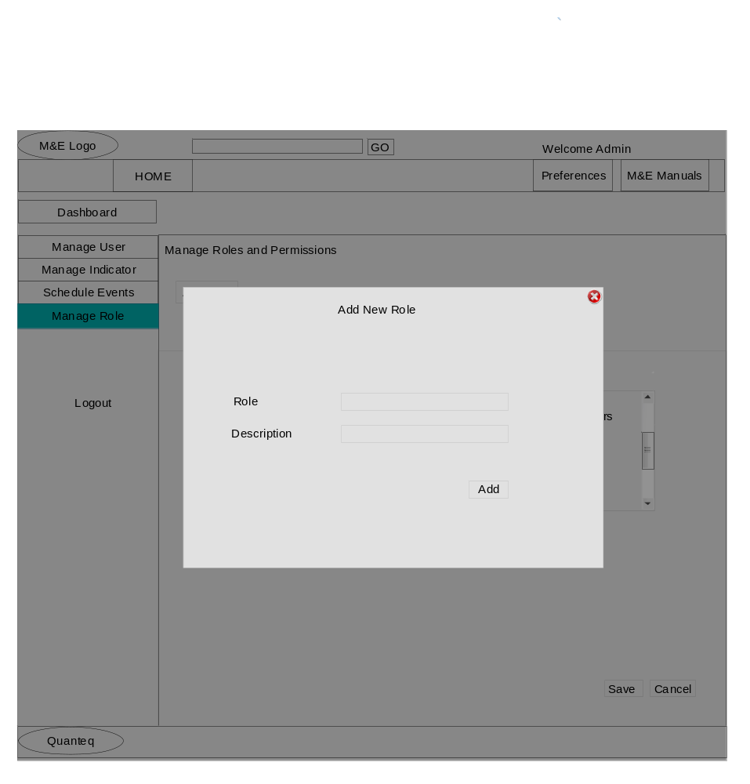Tap the add new button to add new role. Enter texts into role and description text fields and click button add to add new role to the system. New role is automatically updated within the role’s combo box field. Click role combo box to view currently added role.

